Edison Robot and Edublocks
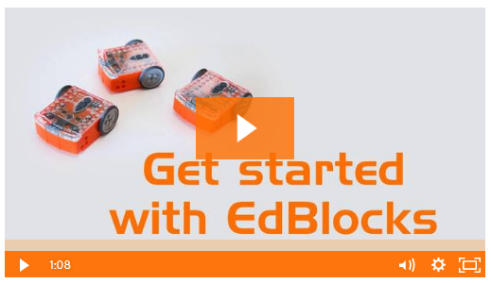
1. Go to: https://www.edblocksapp.com/

2. Watch the short video:

3. Load Demos & explore the coding blocks

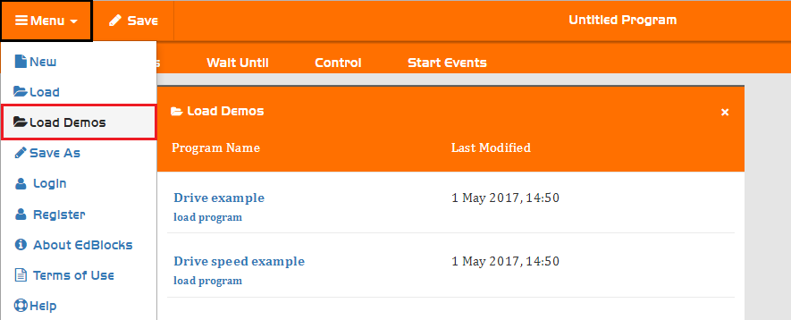

Demo - Drive Speed Example
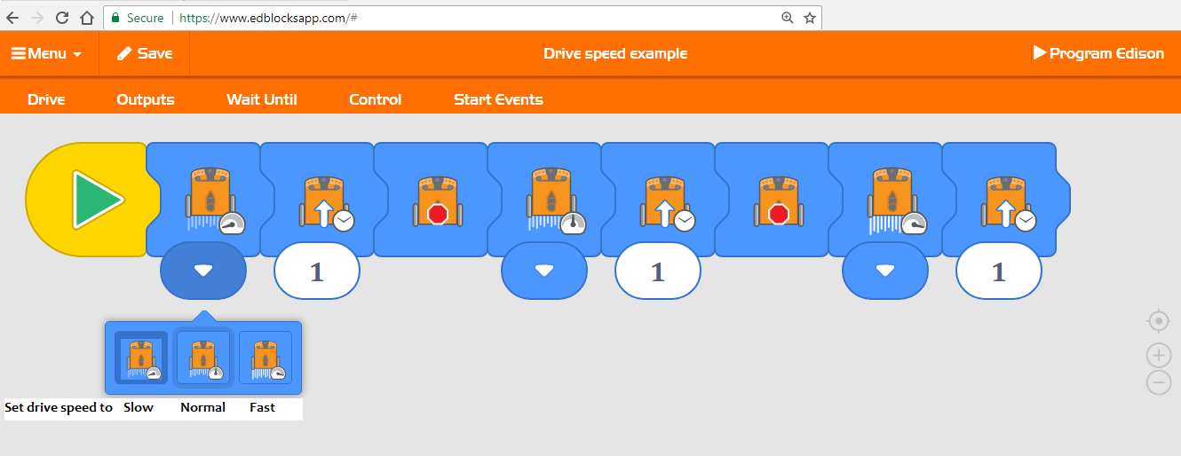

Want to try one of the Demo coding examples?
Follow the UPLOAD instructions sheet.

Get Creative and Build Your Own Edison Program
Drag & Drop from the Menus
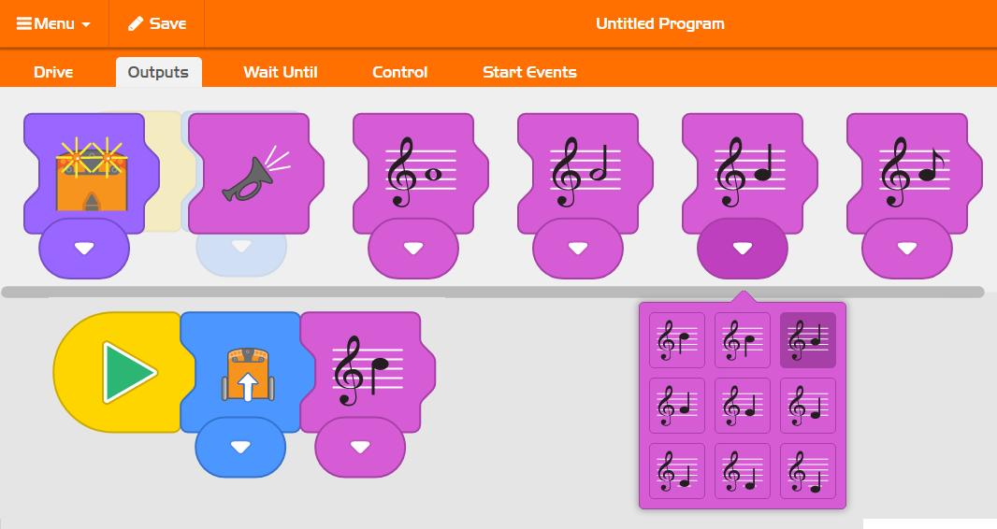
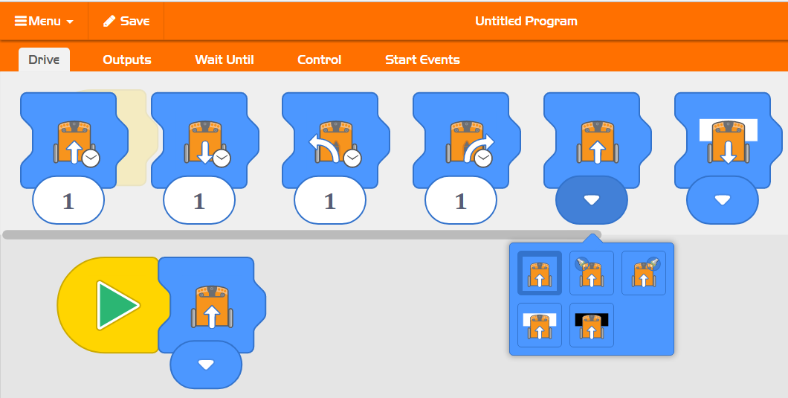

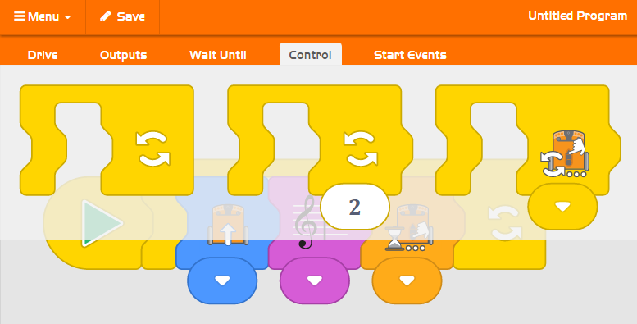
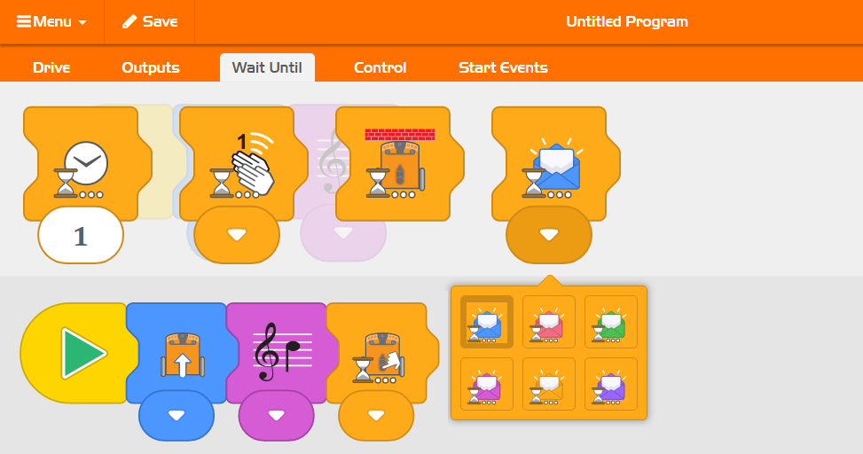

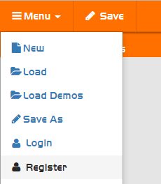

To SAVE your project you will need to REGISTER

Try Another Demo

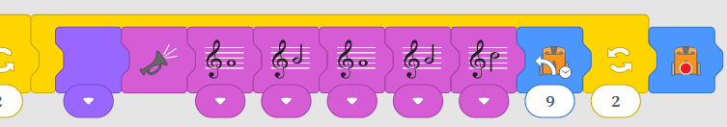
Procedures: Drive forward, put on left blinker, turn left, stop, drive forward, put on right blinker, drive right x 2, stop, play tune , turn in circles to the left x 2, stop
cont.
Why not experiment with Edison’s built-in programs using our Ed Mat
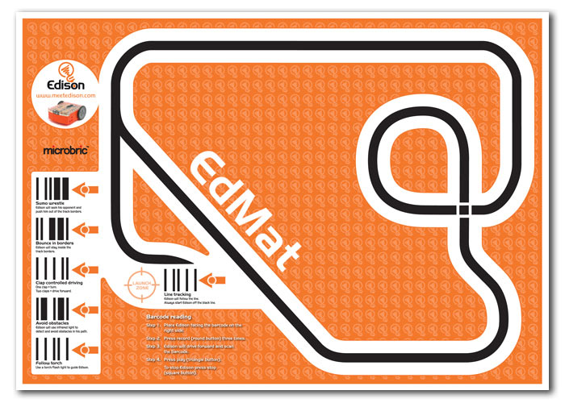

Using the EdMat Edison can:
- Follow the track
- Avoid the lines
- Sumo wrestle
- Clap controlled driving
- Avoid obstacles
- Follow torch light

See instructions on
the EdMat

Upload Your Program to Edison
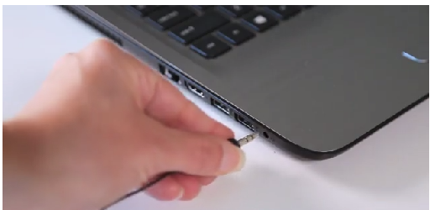

1. Connect the EdCom cable to your PC

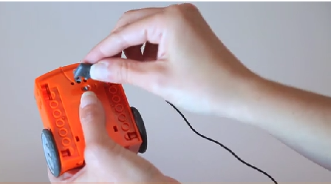

2. Connect the EdCom cable to your Edison

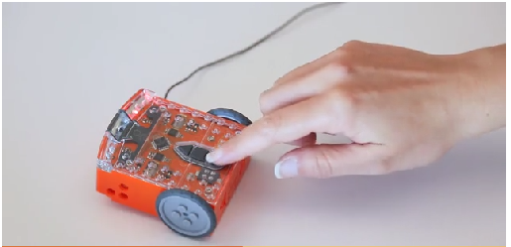

3. Press the round Record Button on Edison
Both lights will be on. Not flashing

4. Click Program Edison

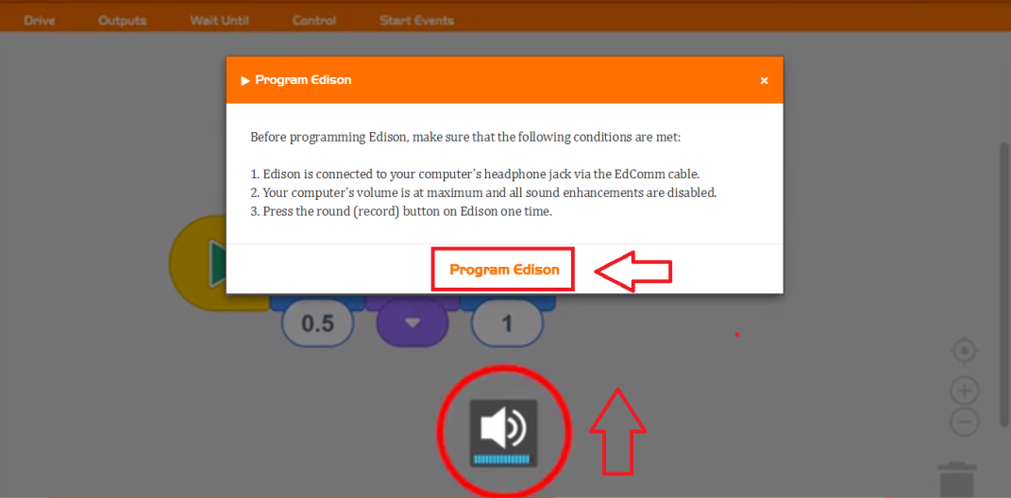

5. Turn your Volume to 100%
&
click Program Edison

6. Lights will go out on your Edison whilst the program is uploading.
Once uploaded the lights will flash alternatively
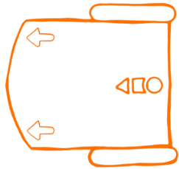

7. Unplug, place on floor and press the triangle button

Edison - Beyond the Basics
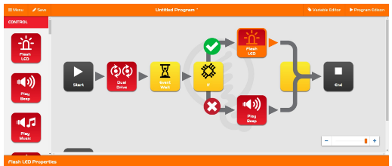
Once the basics are mastered in Edblocks code, Edison can be coded using:
- EdWare: a hybrid coding language that combines the
ease of drag-and-drop graphical icons with text-based entry

- EdPy: a highly versatile text-based
Ed.Drive(Ed.FORWARD, Ed.SPEED_5, Ed.DISTANCE_UNLIMITED)
#read obstacle detection state into a variable
programming language based on Python

Build Projects with Lego

