Do Amazing Things with Makey Makey

Watch: http://bit.ly/2hdjjbN

The Makey Makey can operate as your keyboard and Mouse

To set up:

- Plug the MaKey MaKey in the USB port of your device.
- Connect alligator clips to the four arrow keys, space bar and mouse.
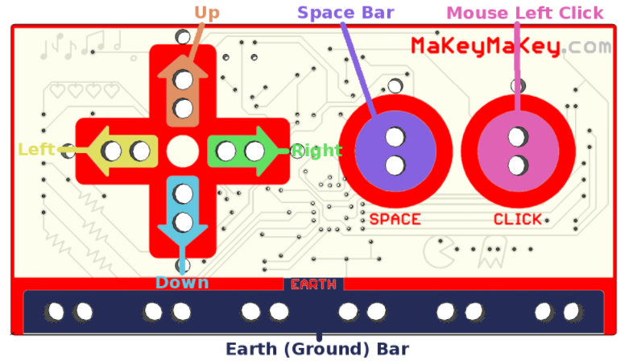
- Also connect one alligator clip to Earth for grounding
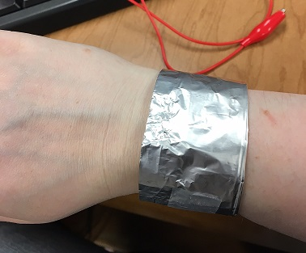

- Connect the other ends of the alligator clips to any conductive material
(Hint: Fruit, vegetables, play dough and lollies work well)
- Hold the end of the Earth alligator clip or attach to foil bracelet

Experiment and enjoy…
Play piano on the connective material via Piano Remix: http://bit.ly/1TjjFX4
Play Pac Man game: http://bit.ly/1XgWo9n
Play Tetris game: http://bit.ly/2fBU0La
Play Whack a Mole: http://bit.ly/2qPCTv2

Why not experiment & try some other Scratch programs with Makey Makey!

