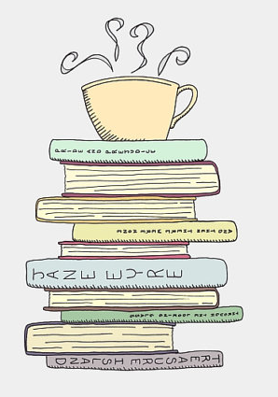
Book Review

Title _____________________________________________

Author __________________________________________

Characters / character development

_____________________________________________________________________________________________________________________________________________________________________________________________________________________________________________________________________________________________

Setting ___________________________________________________
_________________________________________________________

Plot Outline (No spoilers) ______________________________________________________________________________________________________________________________________________________________________________________________________________________________________________________________________________________________________________________________________________________

Why you enjoyed the book / or disliked it ___________________________________________________________________________________________________________________________________________________________________________

Rate out of ten ________________

Recommended age range _________________

Your name __________________________________________________________________

