How to Write a Recount

- First determine whether it is a Factual or a Personal Recount. Factual Recounts are written in the 3rd person (he, she, it, they). Personal Recounts are written in the first person (I, we). In History topics we use Factual Historical Recounts
- Determine the structure of your Recount: Orientation, Events, Re-orientation (See more on Structure below).
- Plan by thinking 'Who? What? When? And Why?'
- Since a recount is a retelling of something that has happened it is written in the past tense
- Start with an Orientation paragraph that informs the reader about the content of the recount.
- Recount events that focus on a specific persons, places or events in chronological order (ie. in the order they occured). (Drawing a flow chart may help you to help sequence events)
- The events form the body of your text. Each paragraph should relate to a particular point. Begin paragraphs with a topic sentence or point. Use the P.E.E.L. technique to write your paragraphs (Point, Explanation, Examples/Evidence, Link).
- Recount only the events that are significant or relevant to the task.
- Use connectives or transition words that signal sequence of time, e.g. then, next, after, meanwhile, finally etc. (See my Writing Tips page for a full list of transition words)
- In your summary end with a Re-orientation and a closing statement that evaluates the events.
- Edit your first draft and use spell check.
- Have someone else edit your second draft.
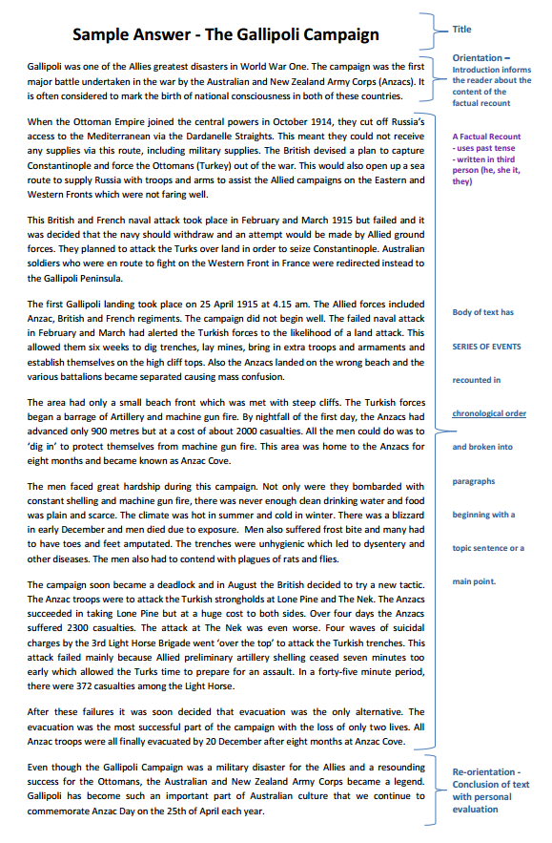
- Make sure you include your Bibliography which includes your primary and secondary sources.
See Factual Recount example below

