Online Search Techniques

Keywords - Experiment with different ______________ of keywords. Try to think of the _______________ words that people might use to talk about (or write about) your topic. Don't give up if the first few combinations of words don't work.
Boolean searches
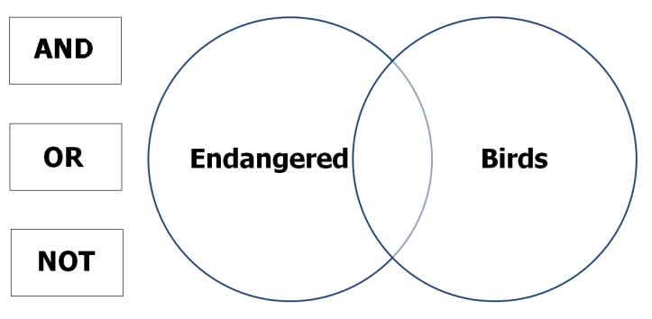
AND - Google automatically uses Boolean AND as the default. That means that a search for endangered birds will be interpreted as endangered AND birds, and will only find pages where ______ of the words appear. This also means that the ______ search terms you use, the _______ results you will get.

When using AND, you only receive pages including both of your search terms , though not necessarily when those terms occur _______ to one another.

OR - When using OR, you only receive pages containing ________ one or both of your ________ terms.
Eg. Endangered OR birds.

NOT - When using the NOT ______________ you receive pages including only the _______ term and not the other. Eg. endangered NOT birds.
NB. In Google search you can also use the _______ (-) symbol instead of NOT Eg. endangered -birds to perform the same operation
Quotation marks - If you're looking for a specific _________, put it in “quotation marks”. For example, if you're looking for information on the Vietnam War and type ____________ quotation marks your search will display ______ page that has the word Vietnam AND the word War ______________ on the page. However, typing "Vietnam War" in quotes will ________ get you pages that list the two words ____________ and in that ______________.
combinations either more search different together order first phrase anywhere only minus fewer without operator any both next

