**C:\Documents and Settings\cathy.costello\Local Settings\Temporary Internet Files\Content.IE5\I2S42RR4\MC900438203[1].wmfBook Review**

**Title of book - Harry Potter and the Philosopher’s Stone**

**Author - J. K. Rowling**

**Main characters**

Name and describe the main characters’ ***appearance*** AND ***personality***

**1. Harry Potter – Wizard born to magical parents but raised by muggles as a muggle. Messy black hair, round glasses, lightening shaped scar on forehead. Smart, resourceful, brave, good hearted.**

**2. Hermione Granger – Muggle born witch. Big bushy brown hair, large front teeth. Bossy, intelligent, kind, stands up for what she believes in.**

**3. Ron Weasley – Grew up in large poor magical family. Red hair, freckles, tall. Loyal, brave, humourous**

**4. Albus Dumbeldore. Hogwarts headmaster. Tall, long white beard & hair. Powerful wizard, well respected, wise, humble, warm and witty.**

**Setting**

Where and when the story takes place [Country/city, present day/past/future]

**Set in modern day England. Privet Drive Little Whinging, Surry and Hogwarts in the north of England (Harry born 1980).**

**Problem/s / Conflict/s**

**- Harry having to cope with neglect, abuse and not feeling like he belonged when living with the Dursleys**

**- Coping with the truth about his parents’ death, being a wizard and the wizarding world, being the ‘boy who lived’ & infamy, new school**

**- Tension with Snape, Draco & Slytherin**

**- Trying to prevent Snape from stealing philosopher’s stone (or so they thought)**

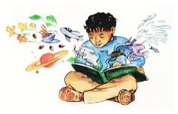

**C:\Documents and Settings\cathy.costello\Local Settings\Temporary Internet Files\Content.IE5\I2S42RR4\MC900438203[2].wmfMain Events**

**- Harry finds out he is a wizard and goes to Hogwarts**

**- Harry makes friend, settles into classes & plays Quidditch**

**- Harry, Ron & Hermione become suspicious of Snape and learns of the Philosopher’s Stone**

**Conclusion / Resolution**

**Harry, Ron & Hermione face and prevent Voldemort from using Philosopher’s Stone and rising to power**

**New words encountered**

Write the word and meaning using a dictionary or dictionary.com

**1 Alchemist – a person who practices Alchemy – a form of chemistry and**

**philosophy practiced in the middle ages**

**2 Vault – a room or chamber for the safekeeping of valuables**

**3 Dormitory – a room containing a number of beds serving as communal sleeping quarters**

**Did you like the book? Why / Why not?**

**Yes very much. It was very well written and the story was gripping and entertaining.**

**Rate out of 5 4 ¾ /5**

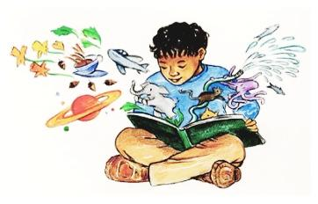**What age would you recommend for this book? 9 – 90 years**