**C:\Documents and Settings\cathy.costello\Local Settings\Temporary Internet Files\Content.IE5\I2S42RR4\MC900438203[1].wmfBook Review**

**Title of book _____________________________________________________**

**Author ____________________________________________________**

**Main characters**

Name and describe the main characters’ ***appearance*** AND ***personality***

**1._______________________________________________________________________________________________________________________________________________________________________________________________**

**2._______________________________________________________________________________________________________________________________________________________________________________________________**

**3._______________________________________________________________________________________________________________________________________________________________________________________________**

**4._______________________________________________________________________________________________________________________________________________________________________________________________**

**Setting**

Where and when the story takes place [Country/city, present day/past/future] ______________________________________________________________________________________________________________________________________________________

**Problem/s / Conflict/s**

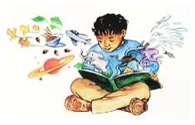_____________________________________________________________________________________________________________________________________________________________________________________________________________________________________________________________________________________________________________________________________________________________________________________________________________________________________________________________________________________________________________________________________________

**C:\Documents and Settings\cathy.costello\Local Settings\Temporary Internet Files\Content.IE5\I2S42RR4\MC900438203[2].wmfMain Events**

_______________________________________________________________________________________________________________________________________________________________________________________________________________________________________________________________________________________________________________________________________________________________________________________

**Conclusion / Resolution**

**________________________________________________________________________________________________________________________________________________________________________________________________________________________________________________________________________________________________________________________________**

**New words encountered**

Write the word and meaning using a dictionary or dictionary.com

**1_______________________________________________________________________________________________________________________________**

**2_______________________________________________________________________________________________________________________________**

**3_______________________________________________________________________________________________________________________________**

**Did you like the book? Why / Why not? ________________________________________________________________________________________________________________________________ ________________________________________________________________**

**Rate out of 5 /5**

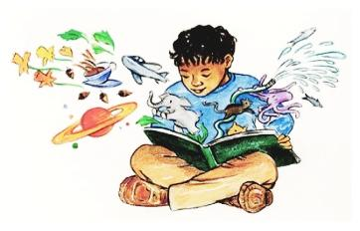**What age would you recommend for this book? _____________**